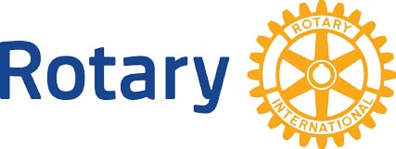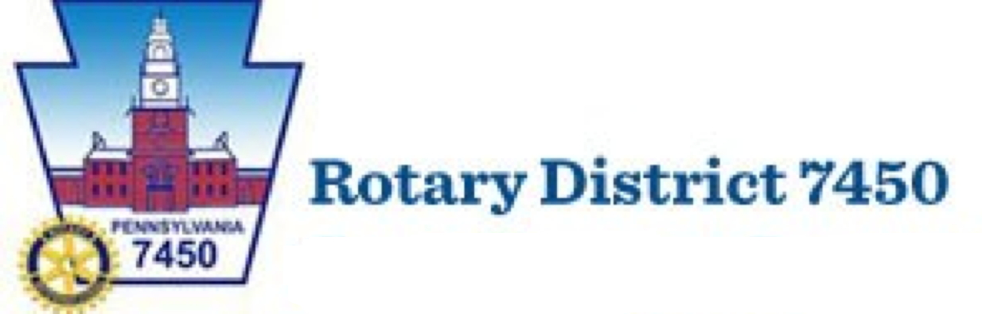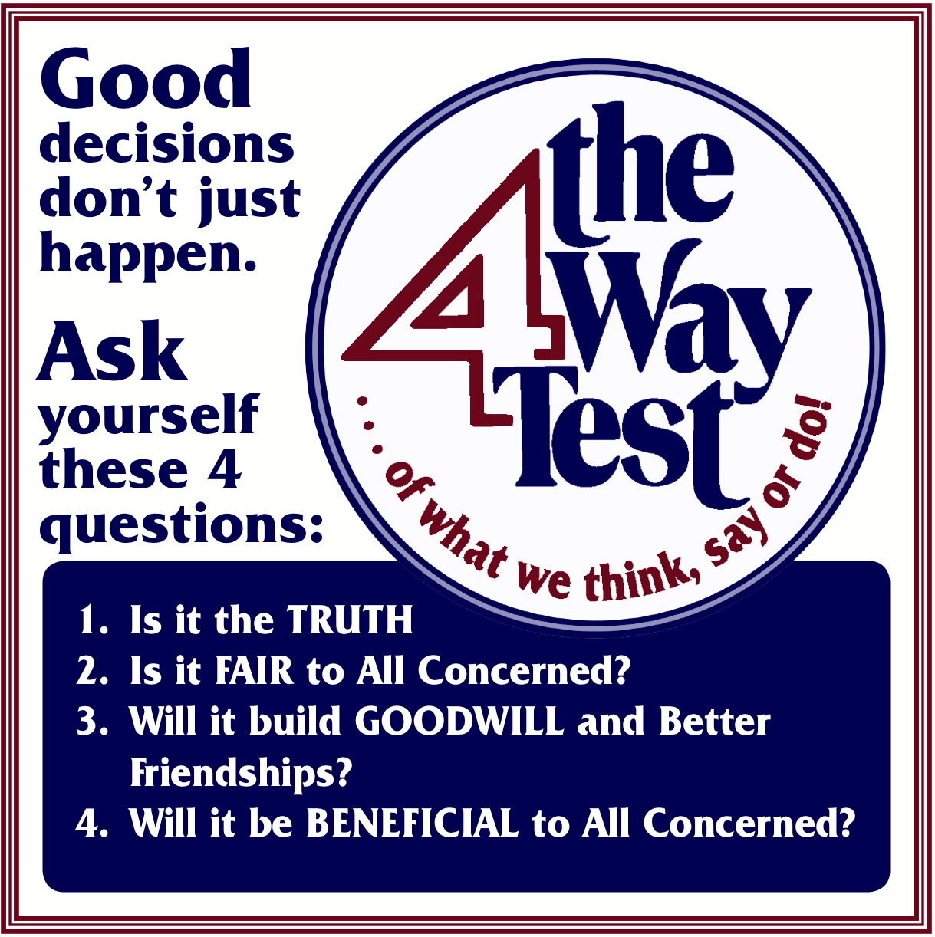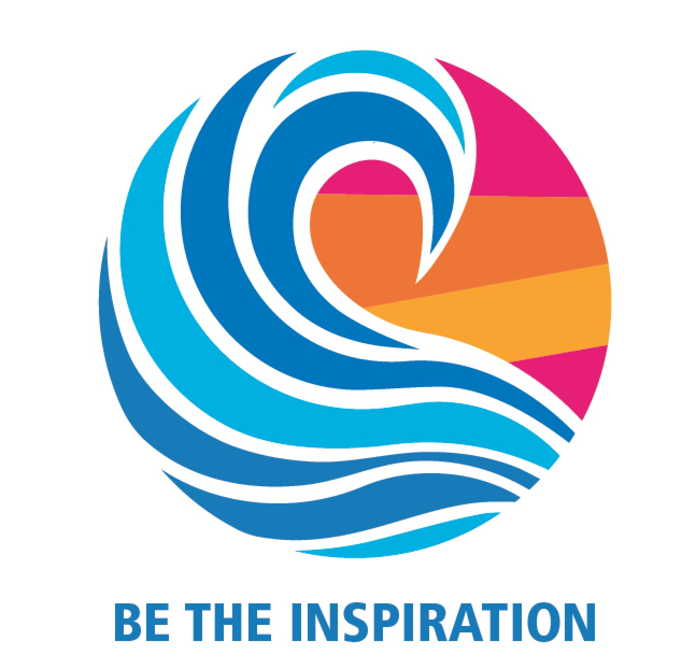

District 7450 contact information

AG Roger Taylor 484-889-1455 - [rogertaylor.rotary@gmail.com](mailto:rogertaylor.rotary@gmail.com) - or - AG Chris Potter 215-601-7433 - insurancepotter@msn.com

The Four-Way Test

The Four Way Test is, put simply, a yardstick code of ethics that helps us to be better Rotarians, better citizens and better friends. Since it’s adoption, the test has been translated into over 100 languages and is used around the world as guiding set of principles.

Imagine a world where everyone used this set of principles to guide their actions.

*Ethics for the Modern World*

How it Works

Participants must be 9th through 12th grade high school students.

Contestants will write/develop a speech on any subject and apply the “Four-Way Test” throughout. The speech must be between 5 and 7 minutes long.

Preliminary contests will be held locally.

Mid-level Competition will be held in late January or early February at a venue to be determined. Registration Fee $75

Winners of the mid-level competition will compete in the Finals at a Rotary District event on the 8th or 9th of February 2019.

The Winner of the Final Competition will deliver their speech to the District 7450 Conference at the Springfield Country Club March 16th 2019

Rotary Four-Way Test

Speech Contest

2018-2019