District and Club Database (Dacdb) Registration and RI Interface Directions
Sign on by using your Email address as the User ID, and your RI Member ID as your Password. (Your RI Member ID is shown on your monthly ROTARIAN magazine just above your name, or you can get it from your club secretary). Once you have registered, just click VIEW MY DATA (under the MEMBER tab), and then you may EDIT/change "your information", including the User ID and Password.
This database is the central reservoir of district information. Whenever a change is made to a club’s or member’s information etc., that change is automatically reflected throughout the database. Here is how different types of district users can change the database:
1. Members | - Maintain their OWN record  - View all public data in Member and Club databases.
2. Club Officers: President, Secretary,  Exec-Secretary, CCO - Club Communications  Officer, the"-elect" officers | - Maintain any member record in their CLUB  - Maintain their CLUB record  - View all data in Member and Club databases  - ADD/DELETE members-any committee in their CLUB  - Export all reports pertaining to their CLUB  - Submit "events" to Club calendar  - Submit "club bulletins"  - PMAIL all their Club members  - PMAIL all their "peers", such as other Club Presidents  - Transfer member records directly to RI
3. Area Assistant Governor | • View all data in Member and Club databases  • Export all reports pertaining to clubs in their Area.  • PMAIL all the Club Presidents in their Area.

INTERFACE WITH ROTARY INTERNATIONAL
Note to Club Officers: President, Secretary, Executive Secretary, the"-elect" officers

DACdb now has the ability to automatically update Club and Member data directly into the Rotary (RI) database…this is called “RI Direct Connect” (which significantly speeds up the updating process. Otherwise, your changes are sent by Email, which is the default method). The updates occur in the RI database within a few minutes after the user clicks the UPDATE button in DACdb (verses a few days using the default Email notification procedures). This is a 2-step process, which MUST be done in this sequence.
First step, go to the Rotary.org web site, and choose MY ROTARY to LOG IN. And, after logging in, click on MANAGE, and then the CLUB ADMINISTRATION link. Once you are on the Club Administration page, click on the VIEW ALL links, then select the Add or remove vendor partner organization link. SCROLL down to the PARTNER ORGANIZATION section, and select DACdb as your integration partner.
Second step, log into DACdb, and EDIT your Club data to select “RI Direct Connect” as the interface option for your Club. This selection is near the bottom of the first club page in EDIT mode.
Once these 2 steps are successfully completed, it is an automated process to interface directly into the RI database any changes entered into the DACdb database that Rotary wants to know about. Also, the RI COMPARE function becomes available, which shows the RI data and the DACdb data “side-by-side” for all your club members.
NOTE: ONLY the current club president, club secretary, or club executive secretary (club officer of record) at RI can make the Partner Organization selection in the Rotary web site. And, the DCO in the district cannot make these selections for their clubs.
Below are the screen shots for both STEP 1 and STEP 2 to assist you in making these selections in both databases.
STEP 1: Choose DACdb as the Partner Organization in the RI database
A current club officer of record accesses the Rotary web site: www.Rotary.org. Then, click on MY ROTARY link to get to the screen with the SIGN IN (or Register)
buttons. Click SIGN IN (or Register) button, and the following screen is displayed. IF you do NOT have an account at Rotary, then first use the CREATE ACCOUNT functions
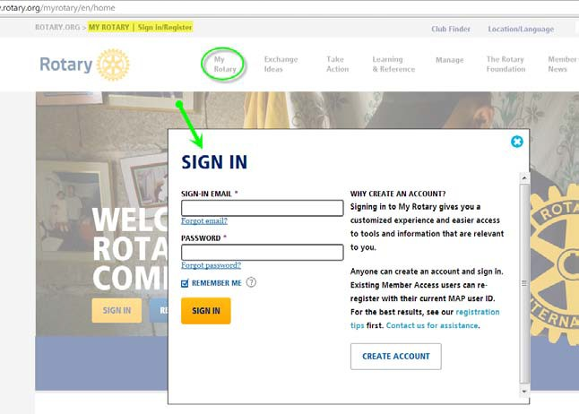

If this is the first time you are logging into the RI database, then you must register by clicking on the CREATE ACCOUNT button. Then, RI will send you an email within a few hours, so you can log in. NOTE: If you have any problems logging into the RI database, THEN you must contact RI for assistance, as we have no capability to help you log into the RI database.
After logging in, click on the MANAGE link, then the Club Administration link, then the VIEW ALL link to see the complete list of choices, and finally select the Add or remove vendor partner organization link. NOTE: Only club officers of record at RI will see these links.
Then near the bottom of the Manage Club Data screen, and then select DACdb from the list of partner organizations…and, then SAVE your selection.
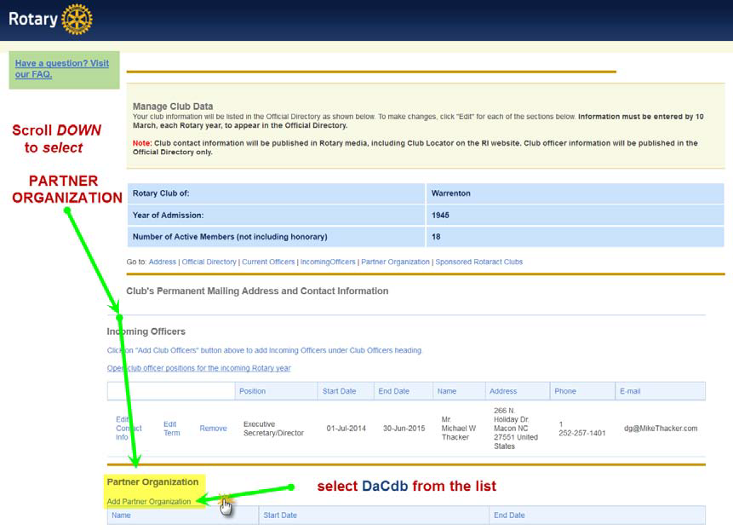
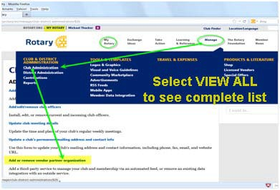
IF you had previously selected another organization, then you must TERMINATE that selection, before you can choose DACdb as your new partner organization.

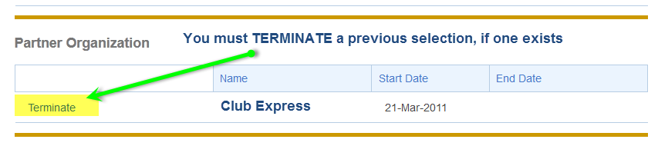
THAT’S IT…you have completed the first step of the RI DIRECT CONNECT processing for your club. Now for STEP 2, to complete the selection process in DACdb.

STEP 2: Choose “RI Direct Connect” in the DACdb database
A current club officer logs into the DACdb database, and then clicks on
the MY CLUB tab. Then, click on the EDIT link to update the interface method.

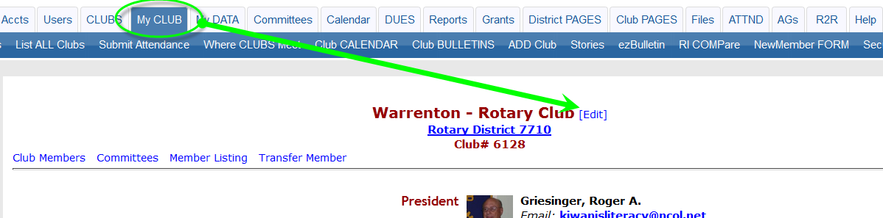

Then, on the INFORMATION page (near the bottom)…click on the Rotary Interface drop down selection, and choose RI “Direct Connect”. Finally, click on the UPDATE button to complete your selection.
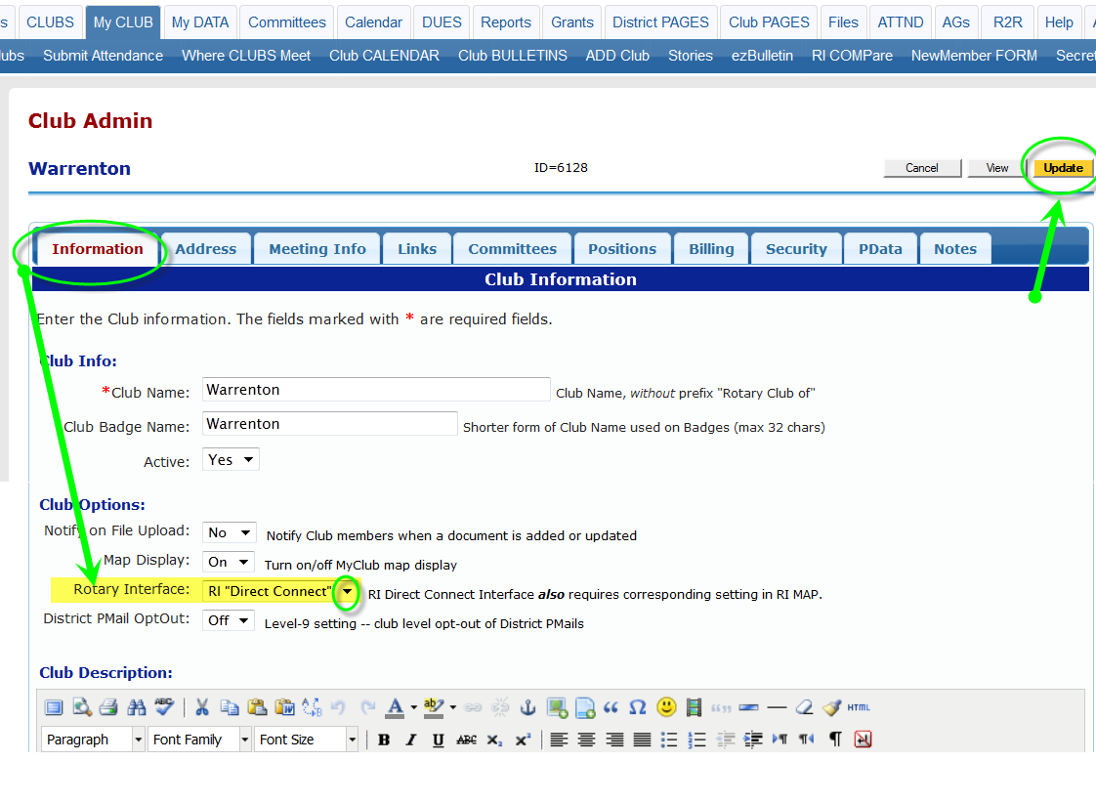
THAT’S IT…Congratulations! You have now completed the 2 steps necessary to activate the interface to update club and member changes entered into DACdb directly into the RI database (usually takes about 24 hours to activate at RI). AND, you also now have the RI COMPARE functions available for your club.

